http://www.paperbeadcrafts.com/beadart/fullpages/cuttingtemplates/Universal/index.shtml
http://www.paperbeadcrafts.com/beadart/beads/pandora/PandoraStyleBeadTemplate.pdf
http://handmade-loveliness.blogspot.com/2011/10/paper-beads.html
http://www.papervinenz.com/2012/07/paper-bead-tutorial-summer-fun.html
http://www.junkmailcanvas.com/diy-paper-bead-rollers.html
You Tube: Beyond Bracelets
PC-PetrifierWood Hardener – strong odor, but makes paper beads very hard and waterproof. Follow with sealer/glaze for shine
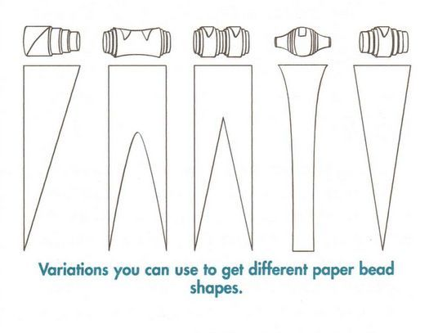
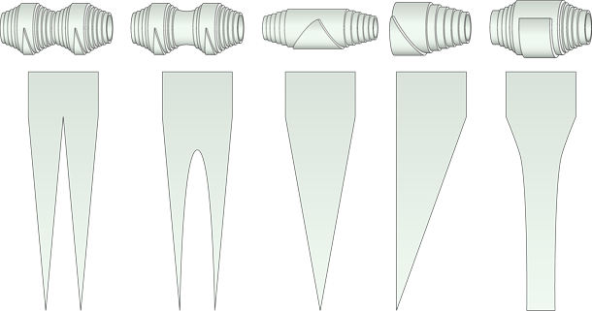
https://www.cutoutandkeep.net/projects/basic-paper-beadsinstructions
